**COIS 2240H Assignment 3  
Modelling Questions**

Question#3: (Total 6 points)

1. Draw a class diagram that models the following: Animals can eat and move. Birds are animals that can fly. Chicken, Eagle, Cow, Rabbit, and Tiger are animals. Chicken and Eagle are birds. Chicken and Cow are edible. You can not create an object of Animal or Bird. Peas and Carrot are Plants. Plants are edible. Tigers eat any Animal, Chicken eat Peas, Cows eat any plant, Rabbits eat Carrot, and Eagle eat any Animal. Make sure to include methods that model behaviours in each class. If something can be modelled using association, the preference should be given to using association. (3 points)

Class Diagram :

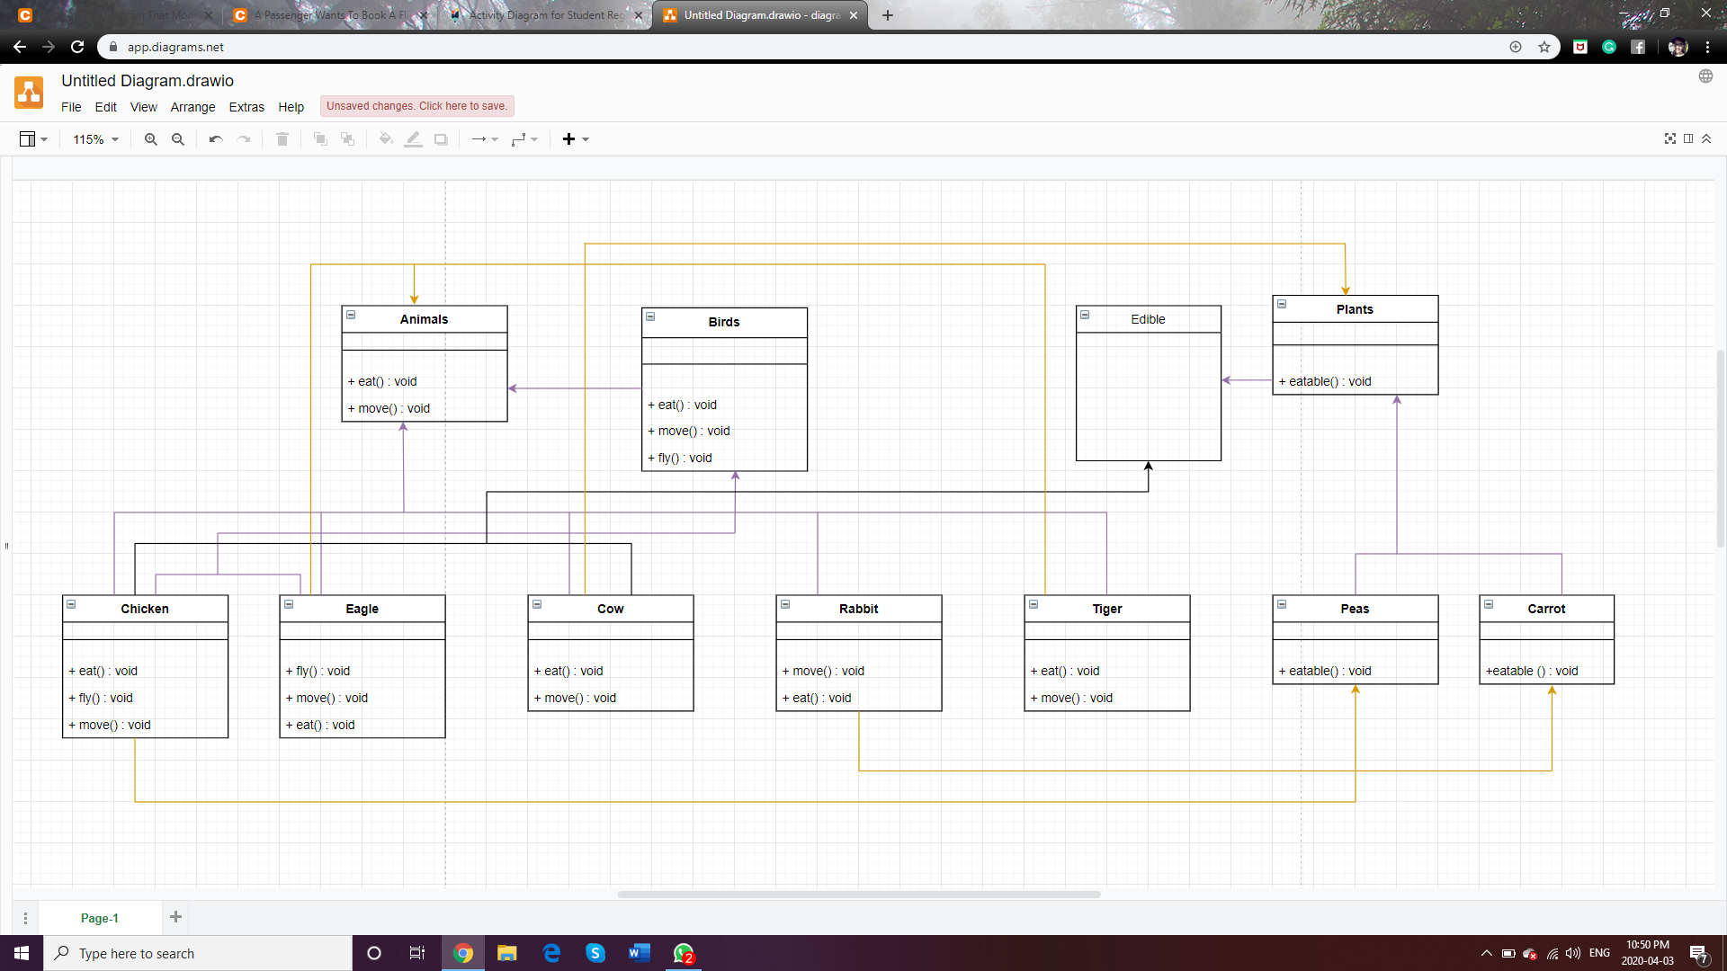

1. Write a Java program that include classes and interfaces for the above scenario. Each concrete class should override the toString() method to print the name of the animal or plant. Edible animals should have a method that returns string called howToEat(). For edible animals, howToEat() should return “roast it” and for plants, this method should return “eat as you wish”. In addition, you have to write a main method in a separate class. In the main method, you have create an object for each animal or plant, and call toString on it. For edibles, you have to print the string returned from howToEat(). (3 points)

Java source code attached in the zip folder

Screenshot of the output :

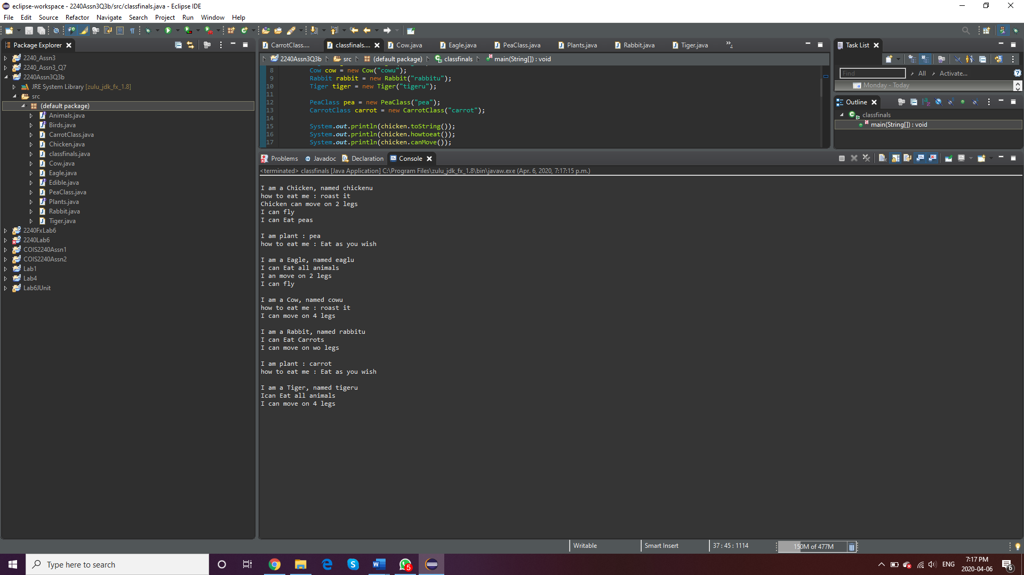

Question#4: (4 points)

A passenger wants to book a flight. First, she checks if the flight has an available seat, if yes, a booking object is created and the passenger is added to the booking object. If the flight doesn’t have available seats, it will create a waitlist object and will add the passenger to the object. Draw a sequence diagram that illustrates this scenario.

Sequence Diagram :

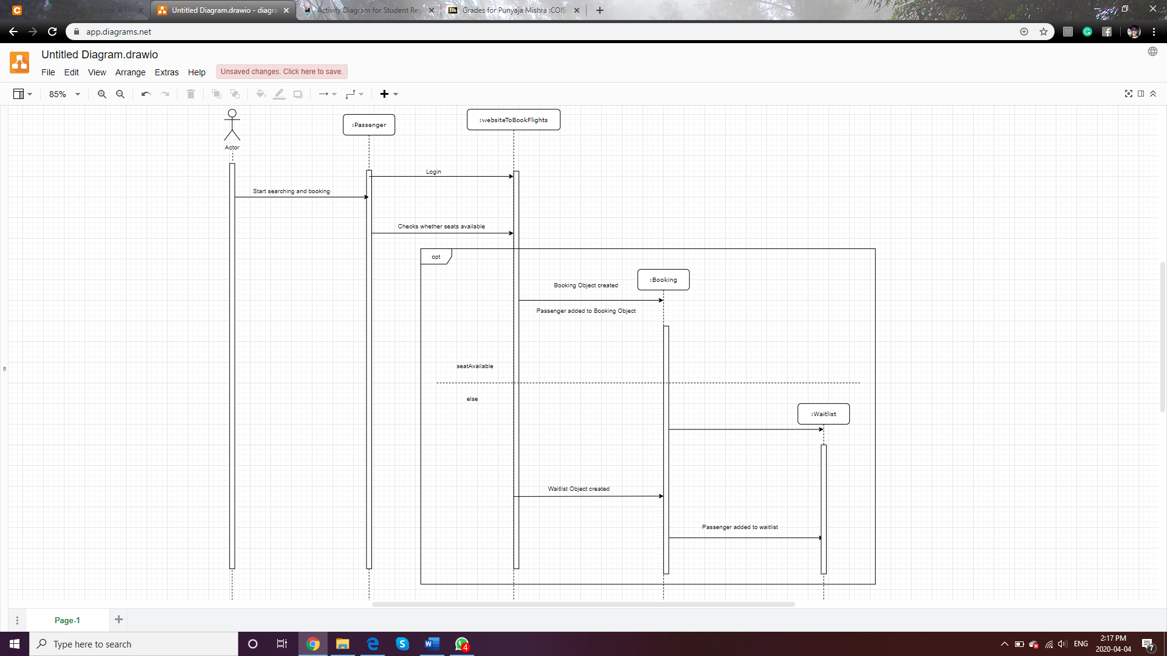

Question#5: (4 points)

In a course registration system, the student enters the course ID and student ID for registration. In parallel, the system verifies if the student has the prerequisites for the course and if the course is not full. If both conditions are fulfilled, the system will register the student in the course and will exit successfully. If one of the conditions is not fulfilled, the system will exit unsuccessfully. Draw an activity diagram that illustrates this scenario.

Activity Diagram :

